

SIMATSENGINEERING
Saveetha Institute of Medical and Technical Sciences Chennai- 602105
Student Name: K.Harika Mythreyi Reg. No.: 192311377
Course Code: CSA1609 Slot: A
Course Name: Data Warehousing and Data Mining
Course Faculty: Dr. A. Moorthy

Project Title: Online Advertising Fraud Detection and Analytics System
Module Photographs:
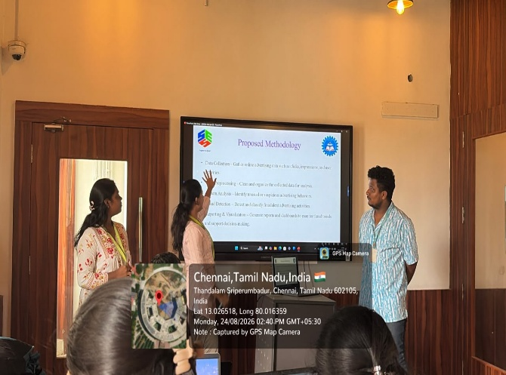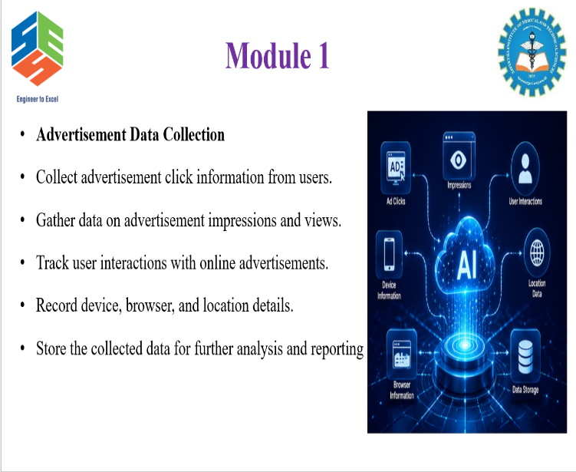

Project Description:
The Advertisement Data Collection module is the first module of the Online Advertising Fraud Detection and Analytics System. It is designed to collect important advertisement-related information required for further fraud analysis. The module captures details such as advertisement clicks, impressions, user interactions, device information, browser information, and location data. The collected information is organized and stored for further processing and analysis by the subsequent modules. This module provides the basic data required to identify unusual traffic and suspicious click patterns. By maintaining structured advertisement activity data, it supports accurate fraud detection, reporting, and analytics in the overall system.

Student Signature Guide Signature

